C3-S5-PRACTICE

# What you will know?

ORDER BY LIMIT SUM COUNT

**Q1:** Create a database named “doctors_appointment_db”

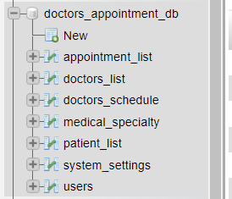

**Q2:** Import “doctors_appointment_db.sql” into phpymyAdmin

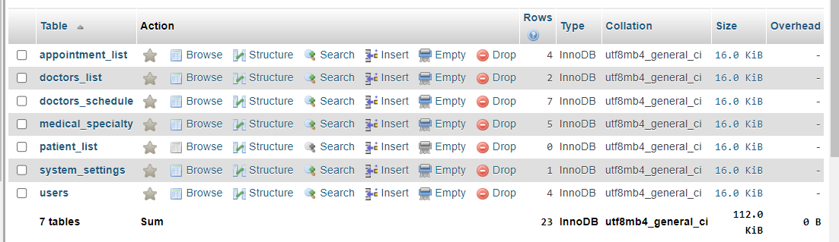

**Q3:** Delete system setting table.

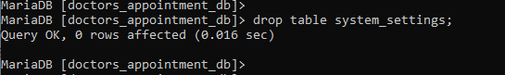

**Q4:** Go to: [mockaroo](https://mockaroo.com/) website

* 1. Create 300 fakes records data for patient list table by having the same patient list in your phpmyAdmin.

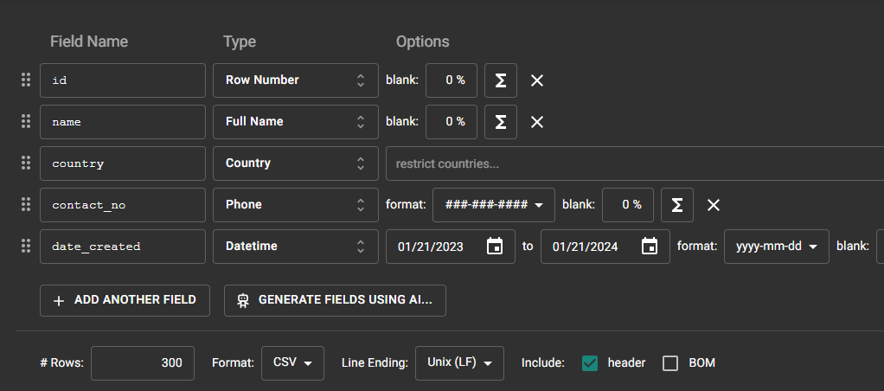

* 1. Import patient_list fake data that you got from mockaroo into doctor_appointment_db into phpMyAdmin

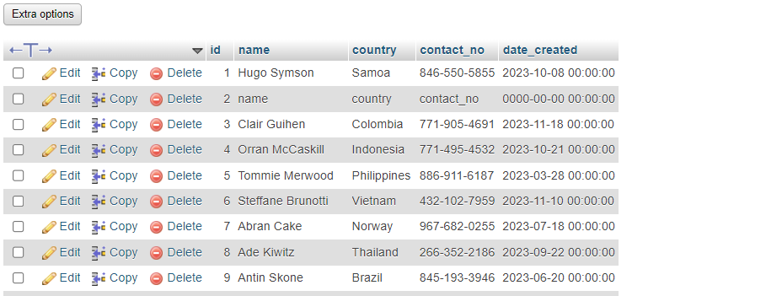

**Q5:** Display the name of the first doctor (alphabetical order) as result below:

Expected result:

Claire Blake

Answer: SELECT * FROM doctors_list WHERE id = 3;

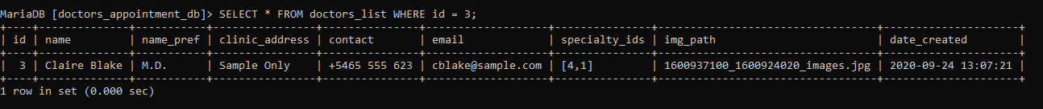

**Q6:** Display the 2 first patients living in France (ordered by their name)

Expected result:

|  |  |
| --- | --- |
| **Name** | **Country** |
| **Charmain Devigne** | **France** |
| **Dredi MacPhaden** | **France** |

Answer: SELECT name, country FROM patient_list WHERE id in (1, 2);

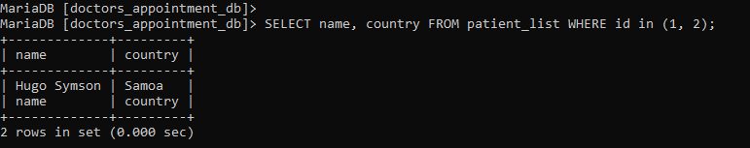

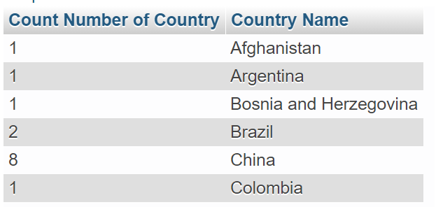**Q7:** display number of patients from each country (order by country) as sample below

Answer: ​ SELECT count(country) AS 'Number of countries' ,country AS 'Country Name' from patient_list group by country;

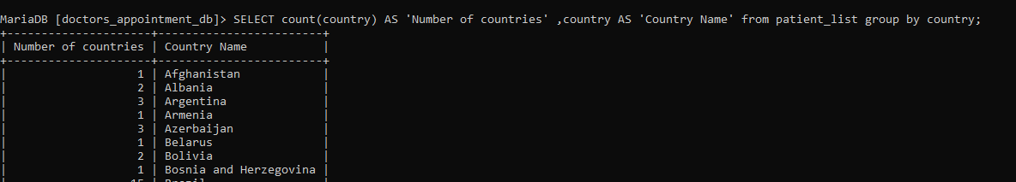

**Q8:** Using the appointment list table, display the total number of appointments

Expected result:

3

Answer: SELECT COUNT(doctor_id) FROM appointment_list;

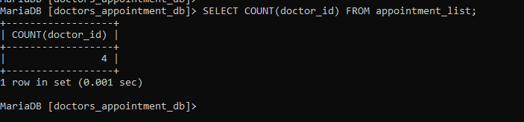

**Q9**: Using the **doctor_schedule** table, display the number of doctors available per day:

Expected result:

**day number of doctors**

Friday 1

Monday 2

Thursday 1

Tuesday 1

Wednesday 2

Answer: SELECT day, doctor_id'number of doctors ' FROM doctors_schedule ;

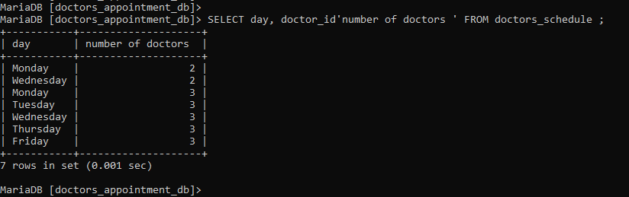

**Q10:** Using the **medical_specialty** table, display the number of medical specialties.

Expected result:

5

Answer: SELECT COUNT(id) FROM medical_specialty;

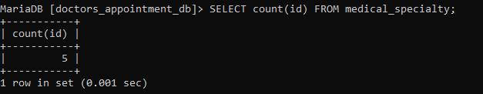

**Q11**: Display the number of appointments scheduled before October 2020.

Answer: SELECT schedule FROM appointment_list WHERE id =9;

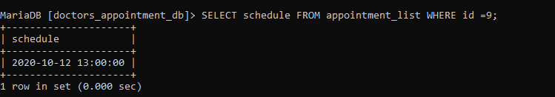

**Q12:** Display all users who have no address and contact.

Expected result:

Administrator

Answer: SELECT name FROM users WHERE name = “Administrator”;

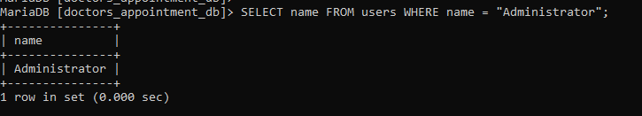

**Q13:** Display the number of patients whose second letter name is ‘e’.

Expected result:

10

Answer: SELECT * FROM patient_list WHERE name like '_e%';

